CRM Dashboard-Calls: This section of the Dashboard lets you create and manage client calls. From the Dashboard, click on Calls on the dark blue toolbar.

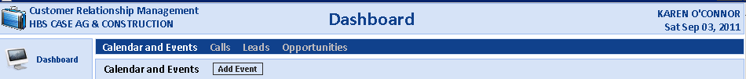

This brings up a full display of all the calls (for an individual salesman or all salesmen). They sort so the most current calls are at the top.

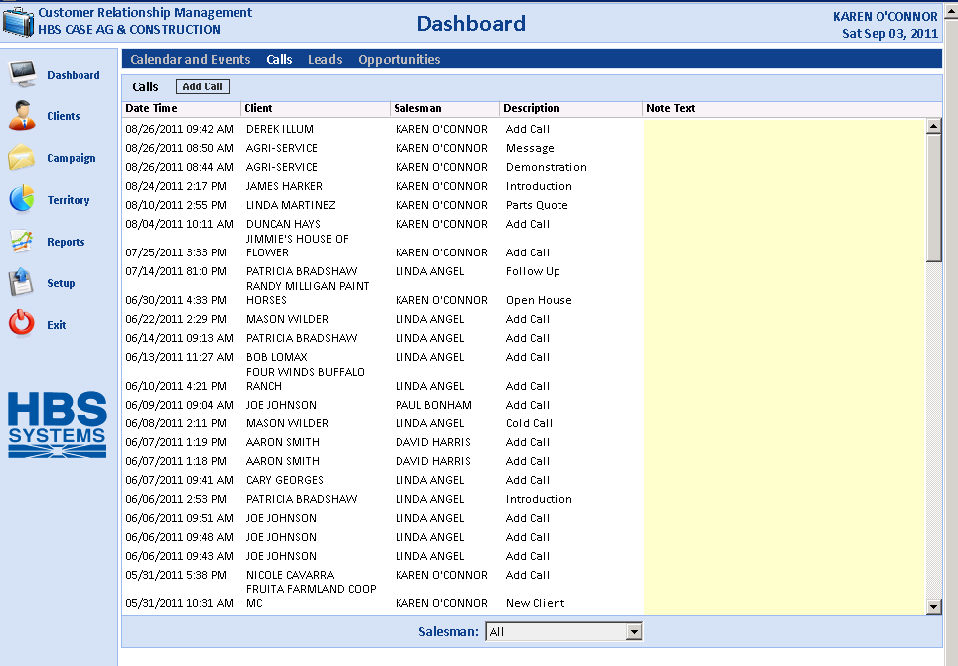

You can review call information by clicking on it.

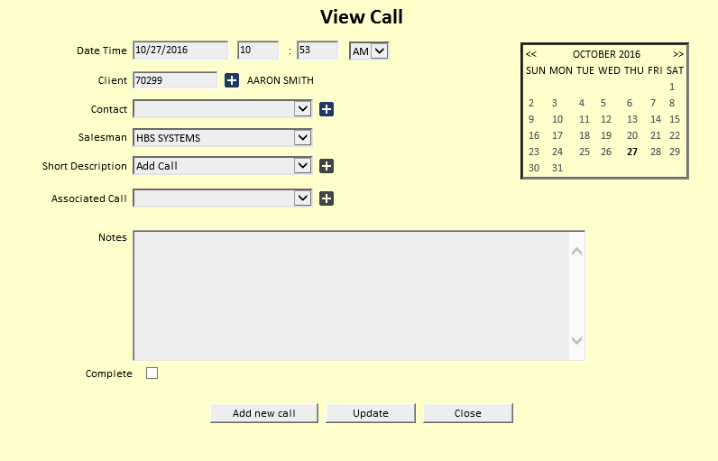

Add a Call: To add a new call, click the Add Call button.

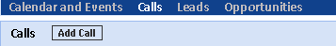

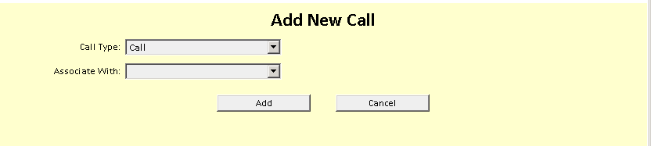

Call Type: Choose from one of the following types:

Call

Lead

Opportunity

Associate with: Choose from either:

Lead

Opportunity

Press the “Add” button to continue to the Call Details.

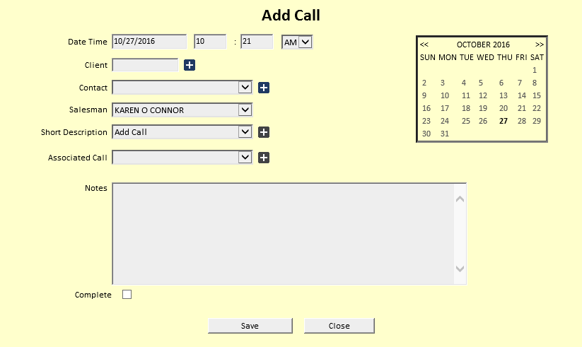

Date and Time: The Date and Time will pre-fill with today's date and the current time. You can change it as needed.

Client: Type in the A/R Customer Number, or look up the customer by typing in a few letters of their last name or business name.

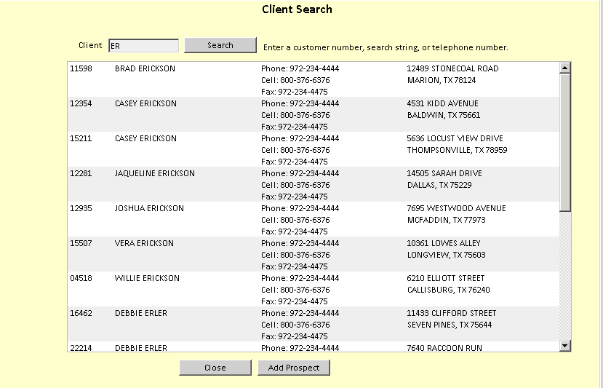

Contact: Choose a contact name from the drop-down menu. If you want to add a new contact:

- Click on the plus (+) sign.
- Fill in the fields that appear.
- Click Save.

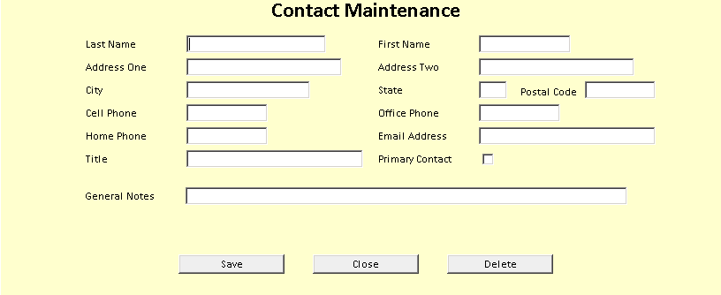

Salesman: The Salesman will default to your login. Sales Managers may choose individual salesman IDs.

Short Description: Choose an option from the drop-down menu.

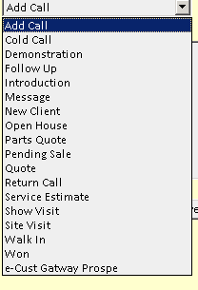

Associated Call: Use this option to connect the call to a previous one.

Choose from either:

Lead

Opportunity

Select the call you want to associate with (if available).

Click Set Associated Call.

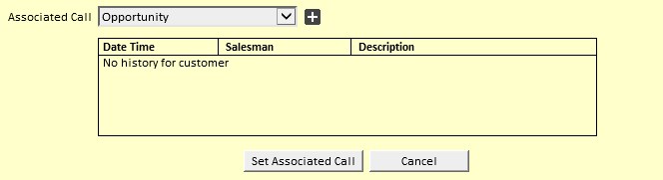

Description: Fill in more details of the call as needed.

Complete: Check this box to switch the call status from Active to Closed.

Press “Save” to record the Call information.

Add from the Client screen: You may also add calls from the Client screen.

Choose a client.

Click Add Call in the lower portion of the screen.

